Table of Contents

The Plan2

Analysis Of Current Data Management3

Problems With Current System4

Proposed Solution5

ERD Narrative7

Entity Relationship Diagram 11

Functional Dependencies12

**Normalized Relations12**

**Normal Form 13**

Screenshot of Relationship View 14

**Tables 15-21**

**Table Data22-26**

**qryReservation and Data28-30**

**qryPackage and Data31-32**

**qryPackageByState and Data33-34**

**Report……………………………………………………………………….34-39**

**Switchboard……………………………………………………………………...40**

**Macros for Switchboard……………………………………………………41-43**

**Conclusion 44**

**Log Sheet 45**

The Plan

WorldView EcoTours (WVET) is an independent company in the hospitality industry that offers guided nature tours to locales around the world. Their current method of recording data is pen and paper; a clerk keeps all the information relating to; individual customers, guides, drivers, tours, new openings and current reservations all in binders. The company is currently trying to expand their business, so would like to move away from their current method of recording-data. With acquiring new customers and scheduling more tours, this will lead to an overflow of information, making the recording of data in binders a tedious process that can later become an unnecessary bottleneck for the organization. The key areas where we’d like to assist Worldview EcoTours automate are all their record keeping for all transactions for their “sell’ side of the business, which is the scheduling of attractive tour packages and booking guests for those packages.

Analysis of current data management practices

WVET current data management allows WVET to keep track of the customer needs and be able to respond to it. They keep all of the descriptions of their packages they sell to their customers. The reason they do that is that it reduce the chances of data redundancy. Also in the package entity they put in how long the customers want to stay. Every entity in their data management has a primary key. The primary key is there to better locate each entity since all primary keys are unique. Even though the package contains the description of their services. They implement a price entity in order to keep track of their prices they offer to their customers. WVET then have an entity called accommodation. The reason is to better meet their customers need. Some customers may want to be in a single supplement room. While some other customers don’t mind to share a room with multiple people. Last entity is driver where the WVET database match the customers with the drivers.

Problems with current system

WVET’s current system has numerous problems. One problem we noticed was how some of the guides fill their schedules up with driving work. With the current system WVET are having everything run through a binder filled with paper, a lot of scheduling conflicts could occur and WVET wouldn’t realize their mistakes till the day of, lowering customer satisfaction. Their current system can be easily damaged, is not flexible at all and lacks the option of sharing data among all the workers. The company and the workers probably have a hard time keeping track of everything and accounting for it. Changes could be made and employees won’t even notice it.  Not only that when customers have a problem and ask employees to pull up the binder, it would be time consuming because they would have to go through the binder instead of a database program that has a search function.

Proposed Solution

There can be a lot of improvements for WVET’s current system. By using a database system, both workers and customers will have an easier and more pleasant time with the company. WVET could automate a lot of things to do automatically instead of manually, like sending an invoice to a guest which could be easily forgotten by an employee. Schedules and itineraries could be updated automatically with the help of the database system. With a database system, they also have the ability to share the information with the whole company instead of the person who has the binder.  It could help the employees locate the important customers and the new comers. And the most important thing with a database improvement is the ability to back up information. With a binder it is almost impossible and probably frustrating to back up. With a database, WVET would have backups to the data and security along with it.

In order to tackle the problems that the company is experiencing, we will create a system that will make it easy look up available tours upon customer’s interest, and show their availability immediately. It will also be easy to track who will be working on that tour and in what position, in order to avoid conflicts such as double scheduling employees. Furthermore, this related database will link automatically link all collected information together so that it will be easy to look up which tours are rather popular in order to schedule them more to achieve higher filling, and also look up individual client’s history with WVET, which will make it easier to track their preferences and maintain great customer relation. There will be no more need research and carry paper binders which hold each tour’s specific description and filling.

We propose our system to WVET with strong faith that it will greatly simplify the lives of the company’s management and employees. Management will have an easier way to track what’s going on in the company, from tour filling to employee assignment, and employees will have it easier than ever to fulfill orders and keep records. This new system, specifically designed to tackle the problems WVET is dealing with, will completely change the way tours are being created and offered to customers. It will allow easy look-up of available tour packages, available space, pricing and other adjustable parameters. Once a customer buys a package all of his information will be stored in the system along with updating the tour package’s occupancy, and automatically invoicing the customer. It will also simplify tracking the scheduling of WVET tour guides and drivers, making it easy to view who will work when, to avoid conflicts.

We’ll also create multiple backups for our database, in case an issue emerges such as a system failure. We need to ensure that WVET has access to their information at all times so they can properly function and operate efficiently.

ERD Narrative

We’d like to create a database that includes the following entities; customers, tour packages, drivers/guides, vehicles and openings. Every customer shall provide the company with information about themselves, whenever they book for a tour package; that information will be recorded in the company’s database. Because Worldview EcoTours expects to have repeat customers, they’ll need an entity in their database that records the customer’s name and interests (which will be determined by tracking their tour history. Worldview EcoTours will need a separate entity for their tour packages available to customers; each package entity should include: package ID, name, description (Hiking, Jeep/ATV and Boat), package length (in terms of nights), tour price and accommodations (tent or hotel/sharing or alone). There should also be a field that determines which packages are most popular, so that WVET can recommend them and schedule more of those tours. WVET must step in and perform a business task that will ultimately determine what tour package a customer wants to select, the duration length a customer wishes to stay, whether or not a customer wishes to share accommodations. This subsequently also determines the total price they charge the customer. WVET generally assumes at least two people will stay in a hotel or tent, which is also their minimum customer requirement for a tour package. If a customer chooses not to share accommodations, they will be prompted to pay a “single supplement”. They also have a maximum number of guests allowed per tour, which they must enforce in order to be consistent with their branding. Once a WVET representative performs that information-gathering task, the collected information should be recorded and inserted into the database under the correct entity/table/field. There will also be a report that is generated to notify the WVET representative when all the openings to a particular tour are close to closing out. WVET also needs an entity that includes the names and descriptions (expertise; for drivers, vehicles they can operate and for guides, knowledge about a particular tour package) for each of their drivers, guides and the different types of vehicles used for transportation in each tour package. WVET needs to step in and arrange the timing and scheduling of each tour, what vehicles will be used, what driver and guide and they must also need to determine certain instances when a tour guide needs to step in the shoes of the driver.



This entity is the package class that is related to the tour class. The package entity holds information about the package such as the name of the package, number of nights, minimum and maximum person allowed in the package, price of package and type of tour. At any given time, a package can have zero to many tours.



This entity is the tour class that is related to the vehicle and package class. The tour class holds information about the tour such as the start and end date of tour. At any given time, a tour can have zero to two vehicles, and has one and only one package.



This entity is of the vehicle class and is related to the tour class. This entity holds the description of vehicle1 and vehicle2 such as make and model. At any given time, a vehicle can have zero to many tours.



This entity is the assignment class that is related to employee and tour class. The assignment entity holds information about which employee is assigned to which tour and whether the employee is a driver or a guide. At any given time, an assignment can be assigned to one and only one tour and employee.



This entity is the guest class that is related to the accommodation class. The guest entity holds information about a guest such as their name and address. At any given time, a guest can have one to many tours.



This entity is the employee class that is related to the assignment class. The employee entity holds information about an employee such as their name, their location and whether they are a guide, driver or both. At any given time, an employee can be assigned to one and only tour.



This entity is the reservation class that is related to customer and tour class. The reservation entity holds the price for single supplement, price per person and total tour price. At any given time, a reservation can have one and only one guest and one and only one tour.

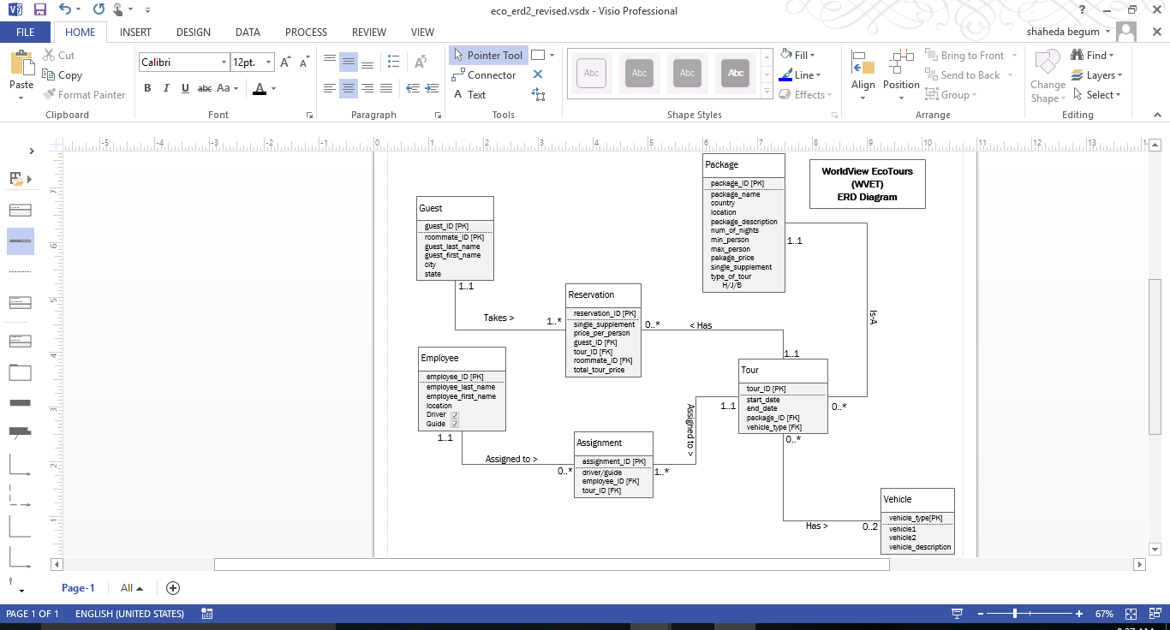

Functional Dependencies

package_ID🡪 package_name, country, location, package_description, num_of_nights, min_person, max­_person, package_price, single_supplement, type_of_tour

tour_ID 🡪start_date, end_date, Package_ID[FK], vehicle_type[FK]

vehicle_type🡪 vehicle_description

assignment_ID 🡪 driver/guide, tour_ID[FK], employee_ID[FK]

guest_ID,🡪 *roommate_ID*, guest_last_name, guest_first_name, city, state

employee_ID 🡪 employee_last_name, employee_first_name, location, guide, driver

reservation_ID🡪 single_supplement, price_per_person, guest_ID[FK], tour_ID[FK], roommate_ID[FK], total_tour_price

Normalized Relations

PACKAGE (package_ID, package_name, country, location, package_description, num_of_nights, min_person, max­_person, package_price, single_supplement, type_of_tour)

TOUR (tour_ID, start_date, end_date, *package_ID, vehicle_type*)

VEHICLE (vehicle_type, vehicle_description)

ASSIGNMENT (assignment_ID, driver/guide, *employee_ID, tour_ID*)

GUEST (guest_ID, *roommate_ID*, guest_last_name, guest_first_name, city, state)

EMPLOYEE (employee_ID, employee_last_name, employee_first_name, location, guide, driver)

RESERVATION (reservation_ID, single_supplement, price_per_person, total_tour_price, *guest_ID, tour_ID, roommate_ID*)

Normal Form

There are no transitive dependencies, therefore the relations are now in 3NF. The methods used to achieve this normal form was by making use of the functional dependencies that exist in relations and the primary key or candidate keys when examining tables.

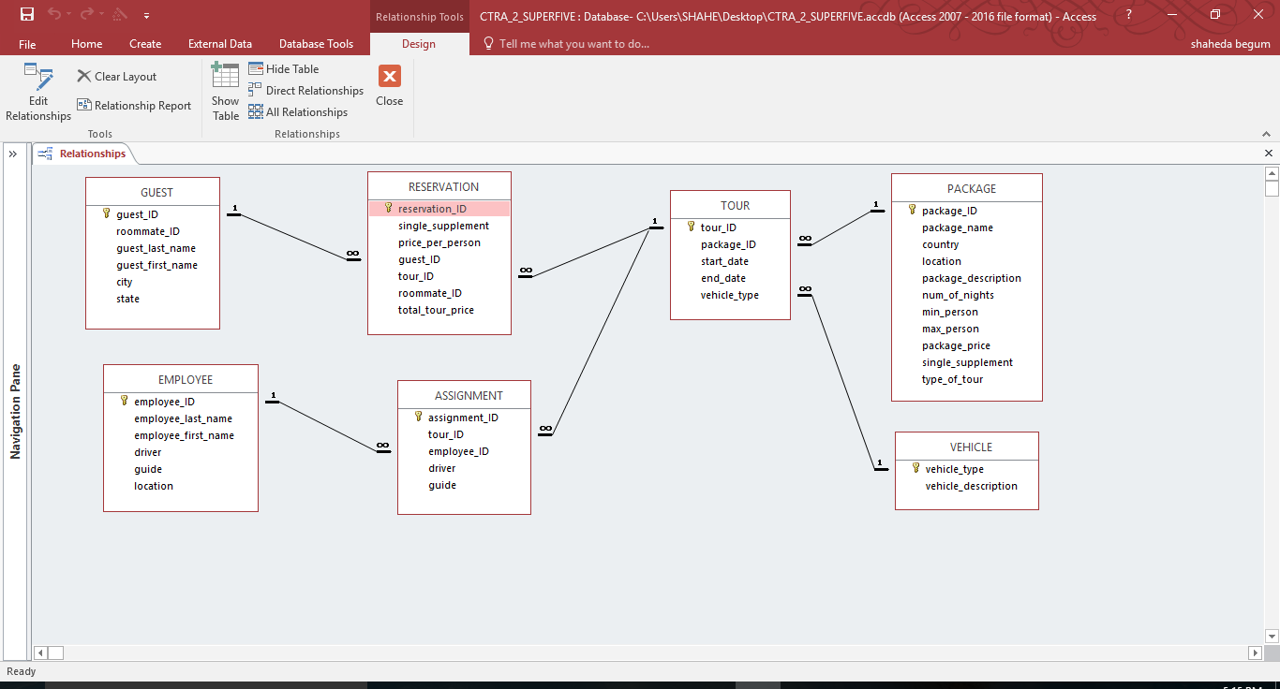

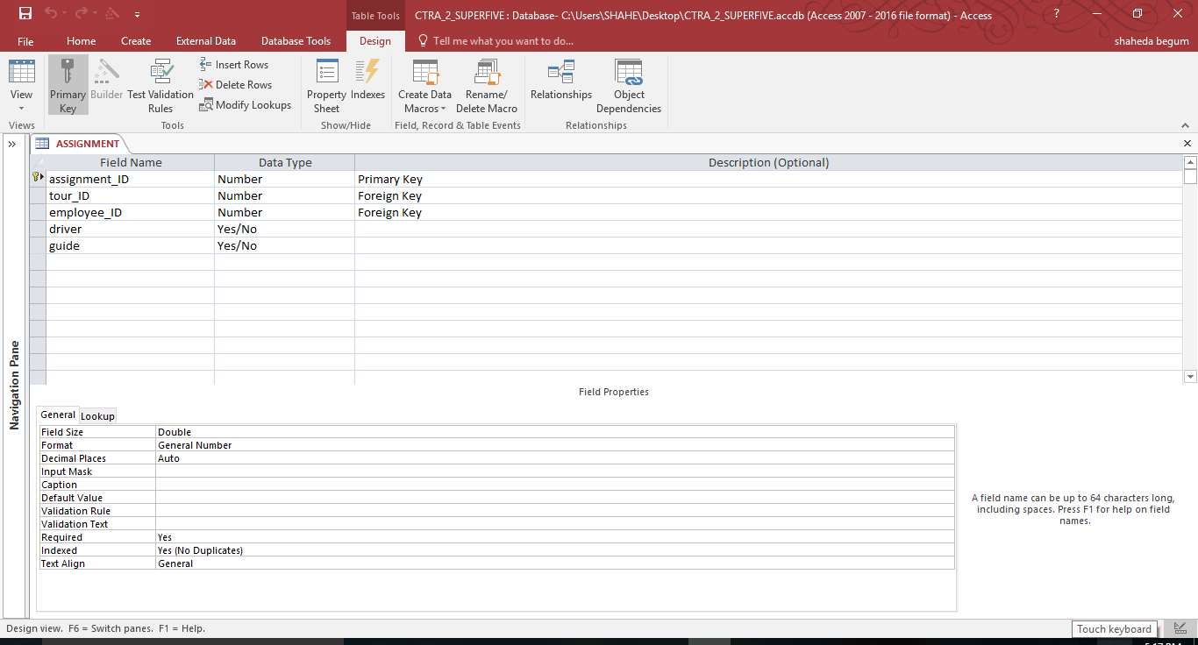

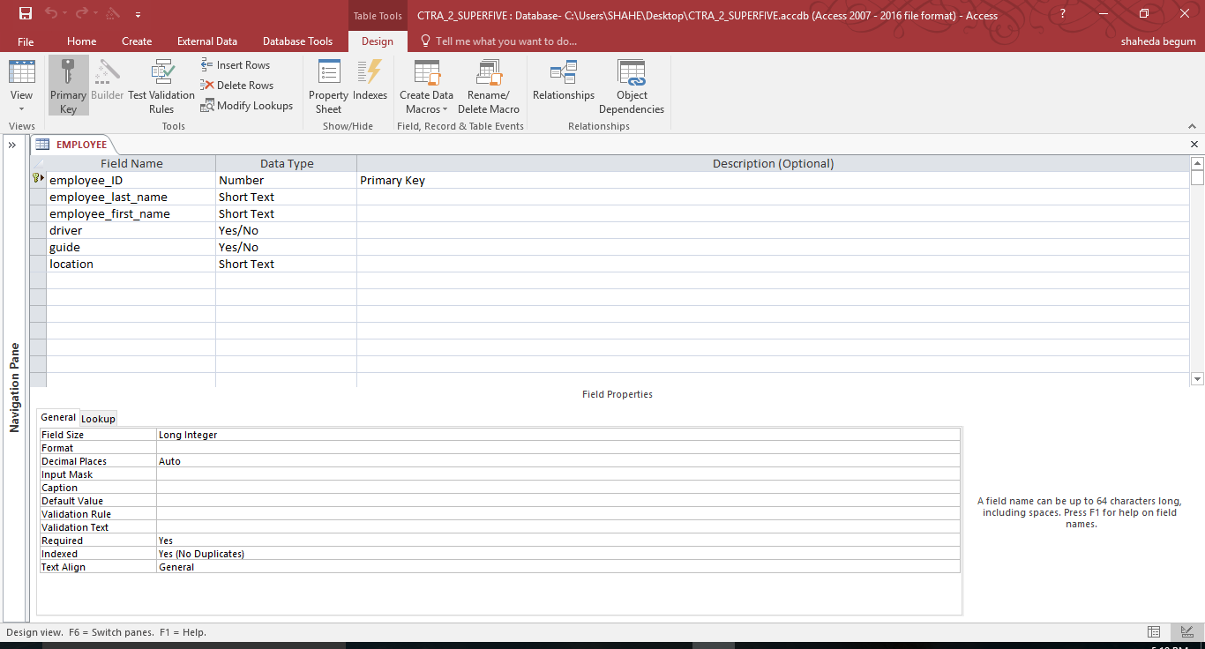

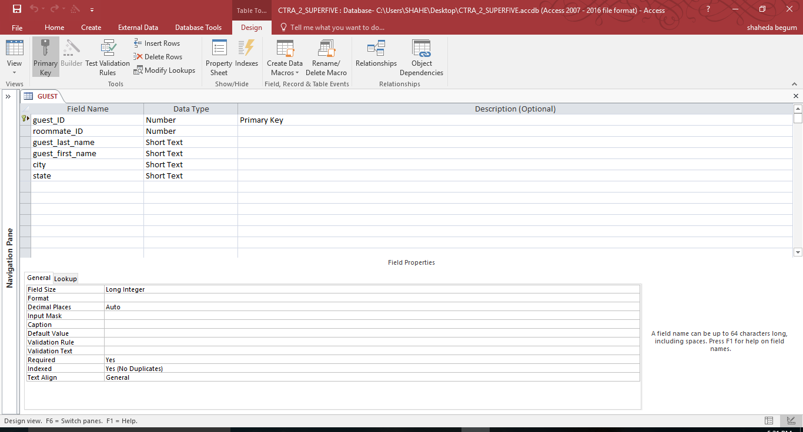

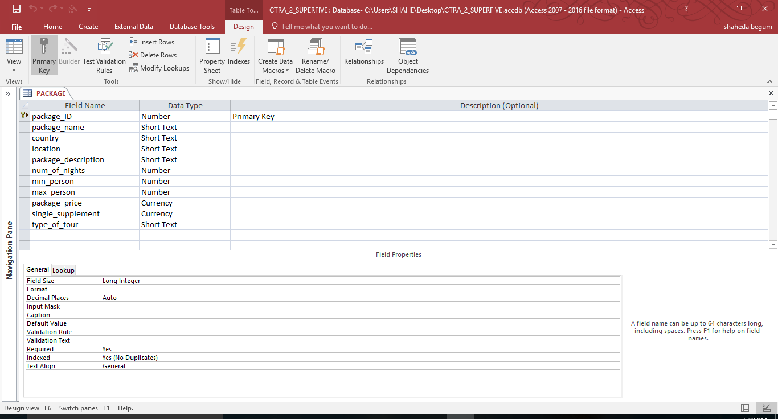

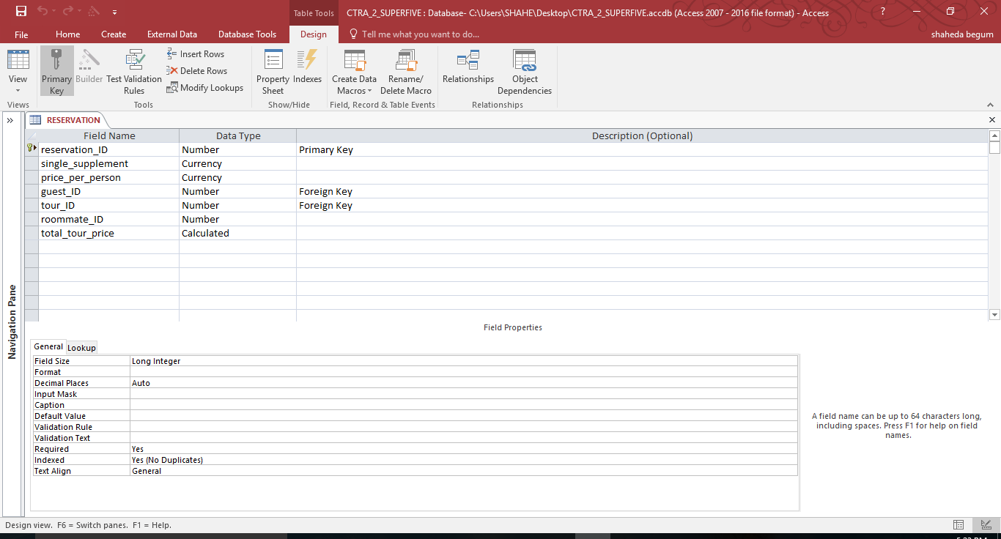

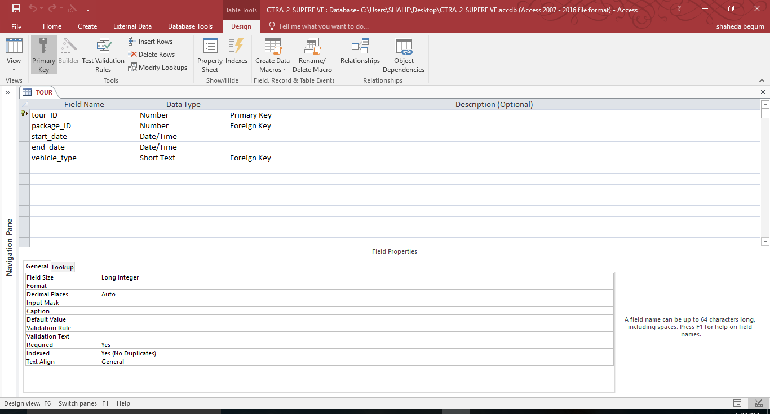

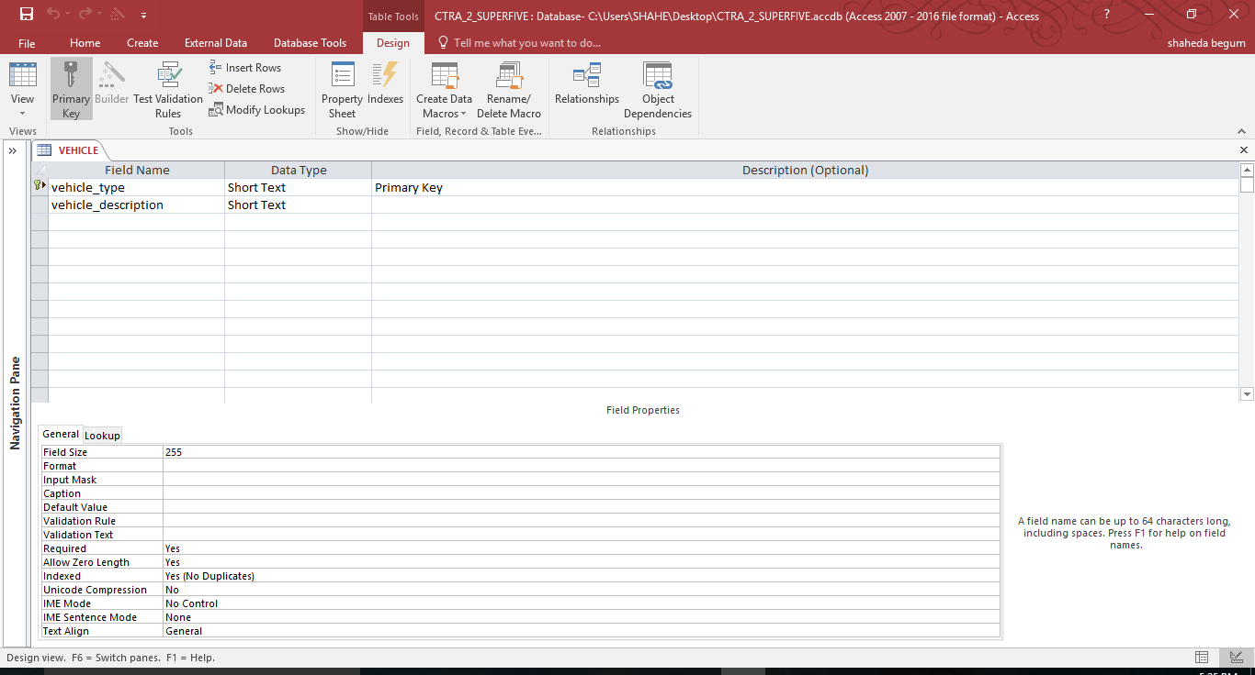

| **ASSIGNMENT** | | | | |
| --- | --- | --- | --- | --- |
| **assignment_ID** | **tour_ID** | **employee_ID** | **driver** | **guide** |
| 1 | 3002 | 3333 | Yes | No |
| 2 | 3002 | 2222 | Yes | No |
| 3 | 3002 | 1111 | No | Yes |
| 4 | 3003 | 4444 | No | Yes |
| 5 | 3007 | 5555 | No | Yes |
| 6 | 3010 | 4444 | No | Yes |
| 7 | 3050 | 6666 | No | Yes |
| 8 | 3050 | 8888 | Yes | No |
| 9 | 3050 | 7777 | Yes | No |
| 10 | 3107 | 8888 | No | Yes |
| 11 | 3107 | 7777 | Yes | No |
| 12 | 3142 | 6666 | No | Yes |
| 13 | 3142 | 8888 | Yes | No |
| 14 | 3142 | 7777 | Yes | No |
| 15 | 3179 | 3333 | Yes | No |
| 16 | 3179 | 9999 | No | Yes |
| 17 | 3179 | 2222 | Yes | No |

| **EMPLOYEE** | | | | | |
| --- | --- | --- | --- | --- | --- |
| **employee_ID** | **employee_Last_Name** | **employee_First_Name** | **driver** | **guide** | **location** |
| 1111 | Khama | Joy | No | Yes | Botswana |
| 2222 | Johnston | Roger | Yes | No | Botswana |
| 3333 | Balde | Jacob | Yes | No | Botswana |
| 4444 | Koyama | Yuka | No | Yes | Miami |
| 5555 | Jacobson | Richard | No | Yes | Miami |
| 6666 | Romano | Annamaria | No | Yes | Peru |
| 7777 | Salazar | Andre | Yes | No | Peru |
| 8888 | Bravo | Diego | Yes | Yes | Peru |
| 9999 | Mwembe | Joseph | No | Yes | Botswana |

| **GUEST** | | | | | |
| --- | --- | --- | --- | --- | --- |
| **guest_ID** | **roommate_ID** | **guest_last_name** | **guest_first_name** | **city** | **state** |
| 401 |  | Student Last | Student First | Riverdale | NY |
| 402 |  | Schmidt | Ingrid | Hoboken | NJ |
| 403 |  | Anderson | Brian | Great Neck | NY |
| 405 |  | Nelson | Leo | Boston | MA |
| 406 |  | Zhu | Li | Great Neck | NY |
| 407 |  | Martinez | Anna | Queens | NY |
| 409 |  | Marceaux | Suzanne | Brooklyn | NY |
| 410 |  | Neto | Luiz | Brooklyn | NY |
| 411 |  | Vanesse | Sarah | New York | NY |
| 412 |  | Froberg | Olivia | Riverdale | NY |
| 415 |  | Gonzales | Jose | Queens | NY |
| 416 |  | Gupta | Sushil | Riverdale | NY |
| 417 |  | Rouy | Isabelle | Hoboken | NJ |
| 419 |  | Higgins | Patrick | Queens | NY |
| 420 |  | Lopez | Alberto | New York | NY |
| 421 |  | DuBrava | Amy | Brooklyn | NY |
| 422 |  | Kalnajs | Ansis | New York | NY |
| 425 |  | Skolnik | Kelly | Fort Lee | NJ |
| 428 |  | Portier | Jacques | New Haven | CT |
| 429 |  | Barry | Paul | New York | NY |
| 430 |  | Davis | Susan | Queens | NY |

| **VEHICLE** | |
| --- | --- |
| **vehicle_type** | **vehicle_description** |
| vehicle1 | JEEP |
| vehicle2 | SNOW MOBILE |

| **PACKAGE** | | | | | | | | | | |
| --- | --- | --- | --- | --- | --- | --- | --- | --- | --- | --- |
| **package_ID** | **package_name** | **country** | **location** | **Package_description** | **num_of_nights** | **min_person** | **max_person** | **package_price** | **single_supplement** | **type_of_tour** |
| 100 | Botswana Wildlife Safari | Botswana | Choe |  | 11 |  |  | $5,500.00 | $1,200.00 |  |
| 101 | Everglades Tour | U.S. | Miami |  | 2 |  |  | $800.00 | $0.00 |  |
| 102 | Machu Picchu Adventure | Peru | Cusco |  | 8 |  |  | $4,300.00 | $650.00 |  |

| **RESERVATION** | | | | | |
| --- | --- | --- | --- | --- | --- |
| **reservation_ID** | **single_Supplement** | **price_per_person** | **guest_ID** | **tour_ID** | **roommate_ID** |
| 503 | $0.00 | $5,500.00 | 409 | 3002 |  |
| 504 | $0.00 | $5,500.00 | 403 | 3002 |  |
| 507 | $0.00 | $5,500.00 | 407 | 3179 |  |
| 510 | $0.00 | $5,500.00 | 411 | 3179 |  |
| 511 | $0.00 | $4,300.00 | 422 | 3142 |  |
| 512 | $0.00 | $4,300.00 | 411 | 3142 |  |
| 513 | $650.00 | $4,300.00 | 409 | 3142 |  |
| 515 | $1,200.00 | $5,500.00 | 402 | 3179 |  |
| 520 | $0.00 | $5,500.00 | 415 | 3179 |  |
| 521 | $0.00 | $5,500.00 | 406 | 3002 |  |
| 522 | $1,200.00 | $5,500.00 | 415 | 3002 |  |
| 525 | $0.00 | $800.00 | 412 | 3010 |  |
| 530 | $0.00 | $4,300.00 | 405 | 3107 |  |
| 531 | $0.00 | $800.00 | 405 | 3010 |  |
| 535 | $0.00 | $800.00 | 401 | 3003 |  |
| 536 | $0.00 | $800.00 | 403 | 3003 |  |
| 537 | $0.00 | $4,300.00 | 410 | 3107 |  |
| 540 | $0.00 | $800.00 | 411 | 3003 |  |
| 541 | $0.00 | $800.00 | 402 | 3003 |  |
| 545 | $650.00 | $4,300.00 | 403 | 3142 |  |
| 548 | $650.00 | $4,300.00 | 430 | 3107 |  |
| 550 | $650.00 | $4,300.00 | 406 | 3107 |  |
| 603 | $1,200.00 | $5,500.00 | 416 | 3002 |  |
| 604 | $1,200.00 | $5,500.00 | 417 | 3002 |  |
| 607 | $0.00 | $5,500.00 | 422 | 3179 |  |
| 610 | $1,200.00 | $5,500.00 | 428 | 3179 |  |
| 611 | $0.00 | $4,300.00 | 401 | 3142 |  |
| 612 | $650.00 | $4,300.00 | 428 | 3142 |  |
| 613 | $0.00 | $4,300.00 | 416 | 3142 |  |
| 615 | $1,200.00 | $5,500.00 | 419 | 3179 |  |
| 620 | $1,200.00 | $5,500.00 | 429 | 3179 |  |
| 621 | $0.00 | $5,500.00 | 421 | 3002 |  |
| 622 | $1,200.00 | $5,500.00 | 429 | 3002 |  |
| 625 | $0.00 | $800.00 | 430 | 3010 |  |
| 630 | $650.00 | $4,300.00 | 420 | 3107 |  |
| 631 | $0.00 | $800.00 | 420 | 3010 |  |
| 635 | $0.00 | $800.00 | 430 | 3003 |  |
| 636 | $0.00 | $800.00 | 417 | 3003 |  |
| 637 | $650.00 | $4,300.00 | 425 | 3107 |  |
| 640 | $0.00 | $800.00 | 428 | 3003 |  |
| 641 | $0.00 | $800.00 | 419 | 3003 |  |
| 645 | $650.00 | $4,300.00 | 417 | 3142 |  |
| 648 | $650.00 | $4,300.00 | 412 | 3107 |  |
| 650 | $0.00 | $4,300.00 | 421 | 3107 |  |

| **TOUR** | | | | | | | | |
| --- | --- | --- | --- | --- | --- | --- | --- | --- |
| **tour_ID** | **tour_name** | **location** | **country** | **nights** | **start_date** | **end_date** | **package_ID** | **vehicle_type** |
| 3002 | Botswana Wildlife Safari | Choe | Botswana | 11 | 04/15/16 | 04/26/16 |  |  |
| 3003 | Everglades Tour | Miami | U.S. | 2 | 04/01/16 | 04/03/16 |  |  |
| 3007 | Everglades Tour | Miami | U.S. | 2 | 04/08/16 | 04/10/16 |  |  |
| 3010 | Everglades Tour | Miami | U.S. | 2 | 04/15/16 | 04/17/16 |  |  |
| 3050 | Machu Picchu Adventure | Cusco | Peru | 8 | 05/01/16 | 05/09/16 |  |  |
| 3107 | Machu Picchu Adventure | Cusco | Peru | 8 | 05/12/16 | 05/20/16 |  |  |
| 3142 | Machu Picchu Adventure | Cusco | Peru | 8 | 06/18/16 | 06/26/16 |  |  |
| 3179 | Botswana Wildlife Safari | Choe | Botswana | 11 | 06/01/16 | 06/12/16 |  |  |

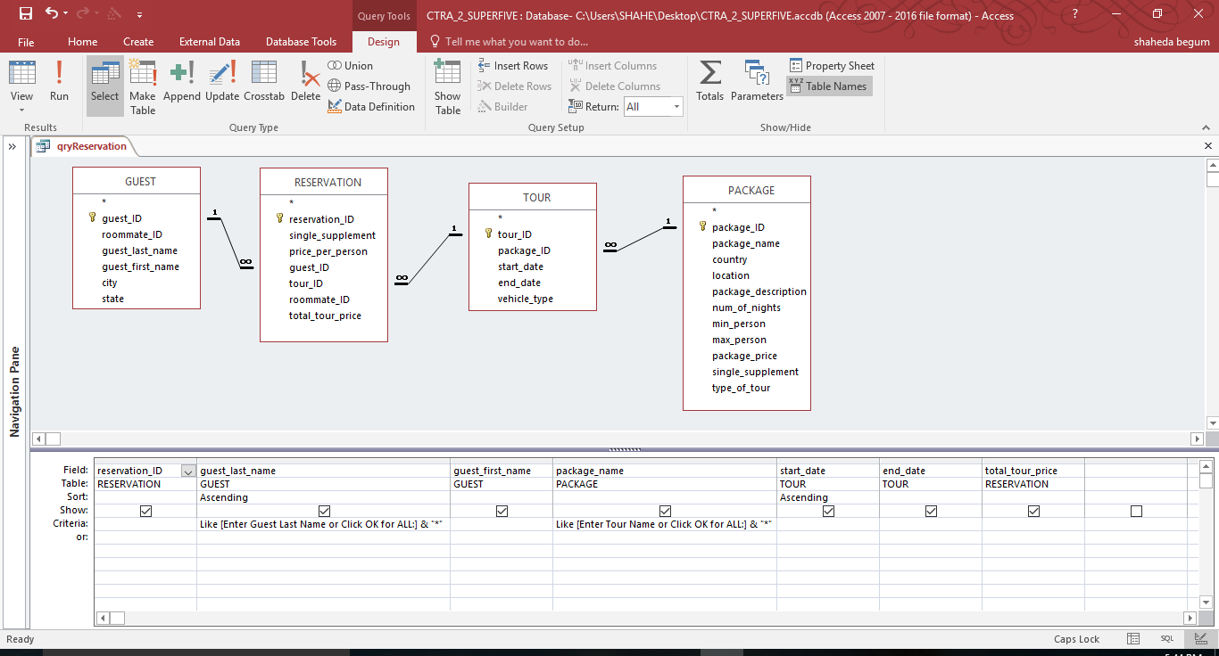

| **qryReservation** | | | | | | |
| --- | --- | --- | --- | --- | --- | --- |
| **reservation_ID** | **guest_last_name** | **guest_first_name** | **package_name** | **start_date** | **end_date** | **total_tour_price** |
| 536 | Anderson | Brian | Everglades Tour | 04/01/16 | 04/03/16 | $800.00 |
| 504 | Anderson | Brian | Botswana Wildlife Safari | 04/15/16 | 04/26/16 | $5,500.00 |
| 545 | Anderson | Brian | Machu Picchu Adventure | 06/18/16 | 06/26/16 | $4,950.00 |
| 622 | Barry | Paul | Botswana Wildlife Safari | 04/15/16 | 04/26/16 | $6,700.00 |
| 620 | Barry | Paul | Botswana Wildlife Safari | 06/01/16 | 06/12/16 | $6,700.00 |
| 535 | Begum | Shaheda | Everglades Tour | 04/01/16 | 04/03/16 | $800.00 |
| 611 | Begum | Shaheda | Machu Picchu Adventure | 06/18/16 | 06/26/16 | $4,300.00 |
| 635 | Davis | Susan | Everglades Tour | 04/01/16 | 04/03/16 | $800.00 |
| 625 | Davis | Susan | Everglades Tour | 04/15/16 | 04/17/16 | $800.00 |
| 548 | Davis | Susan | Machu Picchu Adventure | 05/12/16 | 05/20/16 | $4,950.00 |
| 621 | DuBrava | Amy | Botswana Wildlife Safari | 04/15/16 | 04/26/16 | $5,500.00 |
| 650 | DuBrava | Amy | Machu Picchu Adventure | 05/12/16 | 05/20/16 | $4,300.00 |
| 525 | Froberg | Olivia | Everglades Tour | 04/15/16 | 04/17/16 | $800.00 |
| 648 | Froberg | Olivia | Machu Picchu Adventure | 05/12/16 | 05/20/16 | $4,950.00 |
| 522 | Gonzales | Jose | Botswana Wildlife Safari | 04/15/16 | 04/26/16 | $6,700.00 |
| 520 | Gonzales | Jose | Botswana Wildlife Safari | 06/01/16 | 06/12/16 | $5,500.00 |
| 603 | Gupta | Sushil | Botswana Wildlife Safari | 04/15/16 | 04/26/16 | $6,700.00 |
| 613 | Gupta | Sushil | Machu Picchu Adventure | 06/18/16 | 06/26/16 | $4,300.00 |
| 641 | Higgins | Patrick | Everglades Tour | 04/01/16 | 04/03/16 | $800.00 |
| 615 | Higgins | Patrick | Botswana Wildlife Safari | 06/01/16 | 06/12/16 | $6,700.00 |
| 607 | Kalnajs | Ansis | Botswana Wildlife Safari | 06/01/16 | 06/12/16 | $5,500.00 |
| 511 | Kalnajs | Ansis | Machu Picchu Adventure | 06/18/16 | 06/26/16 | $4,300.00 |
| 631 | Lopez | Alberto | Everglades Tour | 04/15/16 | 04/17/16 | $800.00 |
| 630 | Lopez | Alberto | Machu Picchu Adventure | 05/12/16 | 05/20/16 | $4,950.00 |
| 503 | Marceaux | Suzanne | Botswana Wildlife Safari | 04/15/16 | 04/26/16 | $5,500.00 |
| 513 | Marceaux | Suzanne | Machu Picchu Adventure | 06/18/16 | 06/26/16 | $4,950.00 |
| 507 | Martinez | Anna | Botswana Wildlife Safari | 06/01/16 | 06/12/16 | $5,500.00 |
| 531 | Nelson | Leo | Everglades Tour | 04/15/16 | 04/17/16 | $800.00 |
| 530 | Nelson | Leo | Machu Picchu Adventure | 05/12/16 | 05/20/16 | $4,300.00 |
| 537 | Neto | Luiz | Machu Picchu Adventure | 05/12/16 | 05/20/16 | $4,300.00 |
| 640 | Portier | Jacques | Everglades Tour | 04/01/16 | 04/03/16 | $800.00 |
| 610 | Portier | Jacques | Botswana Wildlife Safari | 06/01/16 | 06/12/16 | $6,700.00 |
| 612 | Portier | Jacques | Machu Picchu Adventure | 06/18/16 | 06/26/16 | $4,950.00 |
| 636 | Rouy | Isabelle | Everglades Tour | 04/01/16 | 04/03/16 | $800.00 |
| 604 | Rouy | Isabelle | Botswana Wildlife Safari | 04/15/16 | 04/26/16 | $6,700.00 |
| 645 | Rouy | Isabelle | Machu Picchu Adventure | 06/18/16 | 06/26/16 | $4,950.00 |
| 541 | Schmidt | Ingrid | Everglades Tour | 04/01/16 | 04/03/16 | $800.00 |
| 515 | Schmidt | Ingrid | Botswana Wildlife Safari | 06/01/16 | 06/12/16 | $6,700.00 |
| 637 | Skolnik | Kelly | Machu Picchu Adventure | 05/12/16 | 05/20/16 | $4,950.00 |
| 540 | Vanesse | Sarah | Everglades Tour | 04/01/16 | 04/03/16 | $800.00 |
| 510 | Vanesse | Sarah | Botswana Wildlife Safari | 06/01/16 | 06/12/16 | $5,500.00 |
| 512 | Vanesse | Sarah | Machu Picchu Adventure | 06/18/16 | 06/26/16 | $4,300.00 |
| 521 | Zhu | Li | Botswana Wildlife Safari | 04/15/16 | 04/26/16 | $5,500.00 |
| 550 | Zhu | Li | Machu Picchu Adventure | 05/12/16 | 05/20/16 | $4,950.00 |

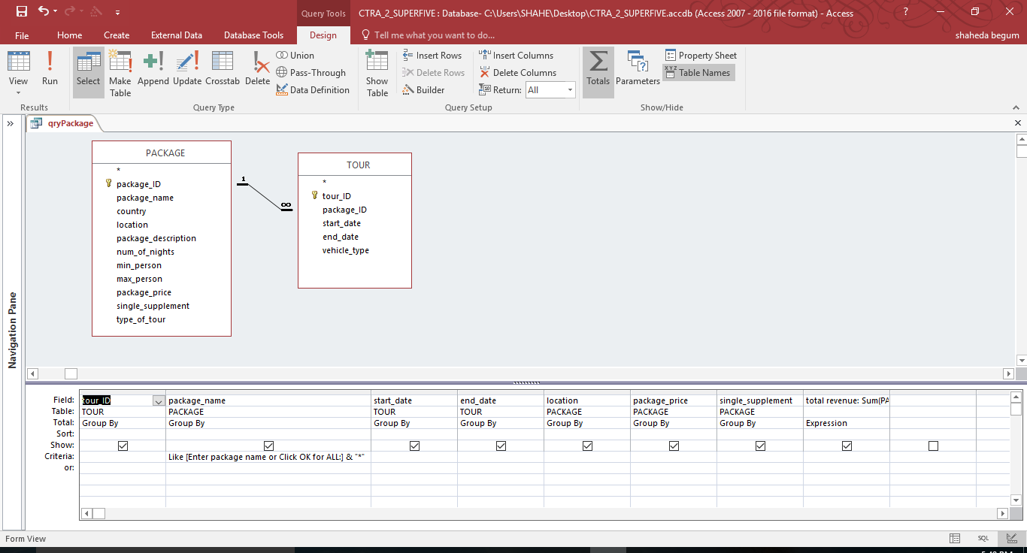

| **qryPackage** | | | | | | | |
| --- | --- | --- | --- | --- | --- | --- | --- |
| **tour_ID** | **package_name** | **start_date** | **end_date** | **location** | **package_price** | **single_supplement** | **total revenue** |
| 3002 | Botswana Wildlife Safari | 04/15/16 | 04/26/16 | Choe | $5,500.00 | $1,200.00 | $6,700.00 |
| 3003 | Everglades Tour | 04/01/16 | 04/03/16 | Miami | $800.00 | $0.00 | $800.00 |
| 3007 | Everglades Tour | 04/08/16 | 04/10/16 | Miami | $800.00 | $0.00 | $800.00 |
| 3010 | Everglades Tour | 04/15/16 | 04/17/16 | Miami | $800.00 | $0.00 | $800.00 |
| 3050 | Machu Picchu Adventure | 05/01/16 | 05/09/16 | Cusco | $4,300.00 | $650.00 | $4,950.00 |
| 3107 | Machu Picchu Adventure | 05/12/16 | 05/20/16 | Cusco | $4,300.00 | $650.00 | $4,950.00 |
| 3142 | Machu Picchu Adventure | 06/18/16 | 06/26/16 | Cusco | $4,300.00 | $650.00 | $4,950.00 |
| 3179 | Botswana Wildlife Safari | 06/01/16 | 06/12/16 | Choe | $5,500.00 | $1,200.00 | $6,700.00 |
|  |  |  |  |  | $26,300.00 | $4,350.00 | $30,650.00 |

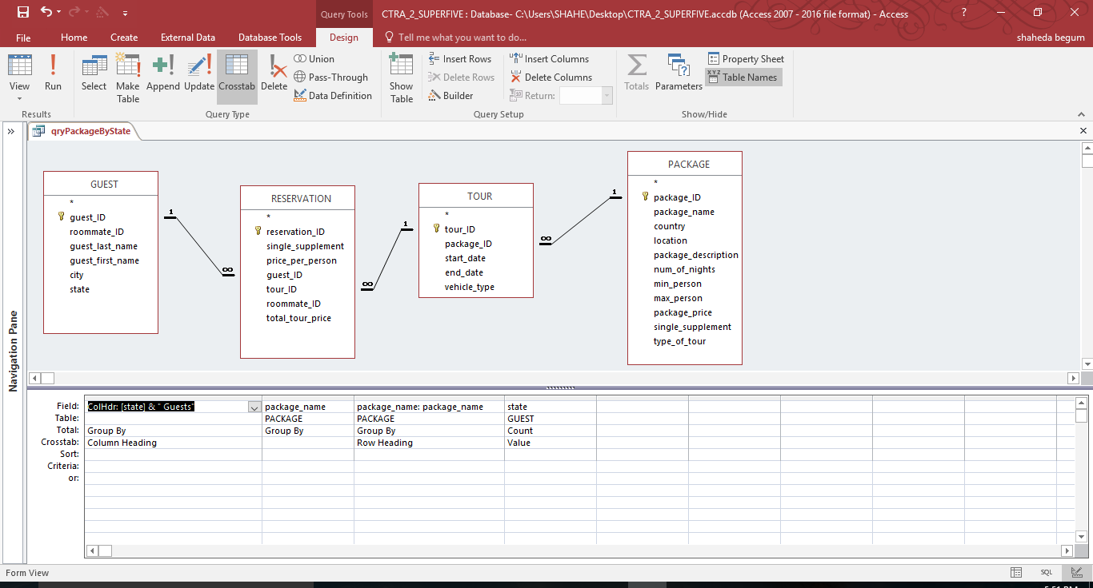

| **qryPackageByState** | | | | |
| --- | --- | --- | --- | --- |
| **Package** | **CT Guests** | **MA Guests** | **NJ Guests** | **NY Guests** |
| Botswana Wildlife Safari | 1 |  | 2 | 13 |
| Everglades Tour | 1 | 1 | 2 | 8 |
| Machu Picchu Adventure | 1 | 1 | 2 | 12 |

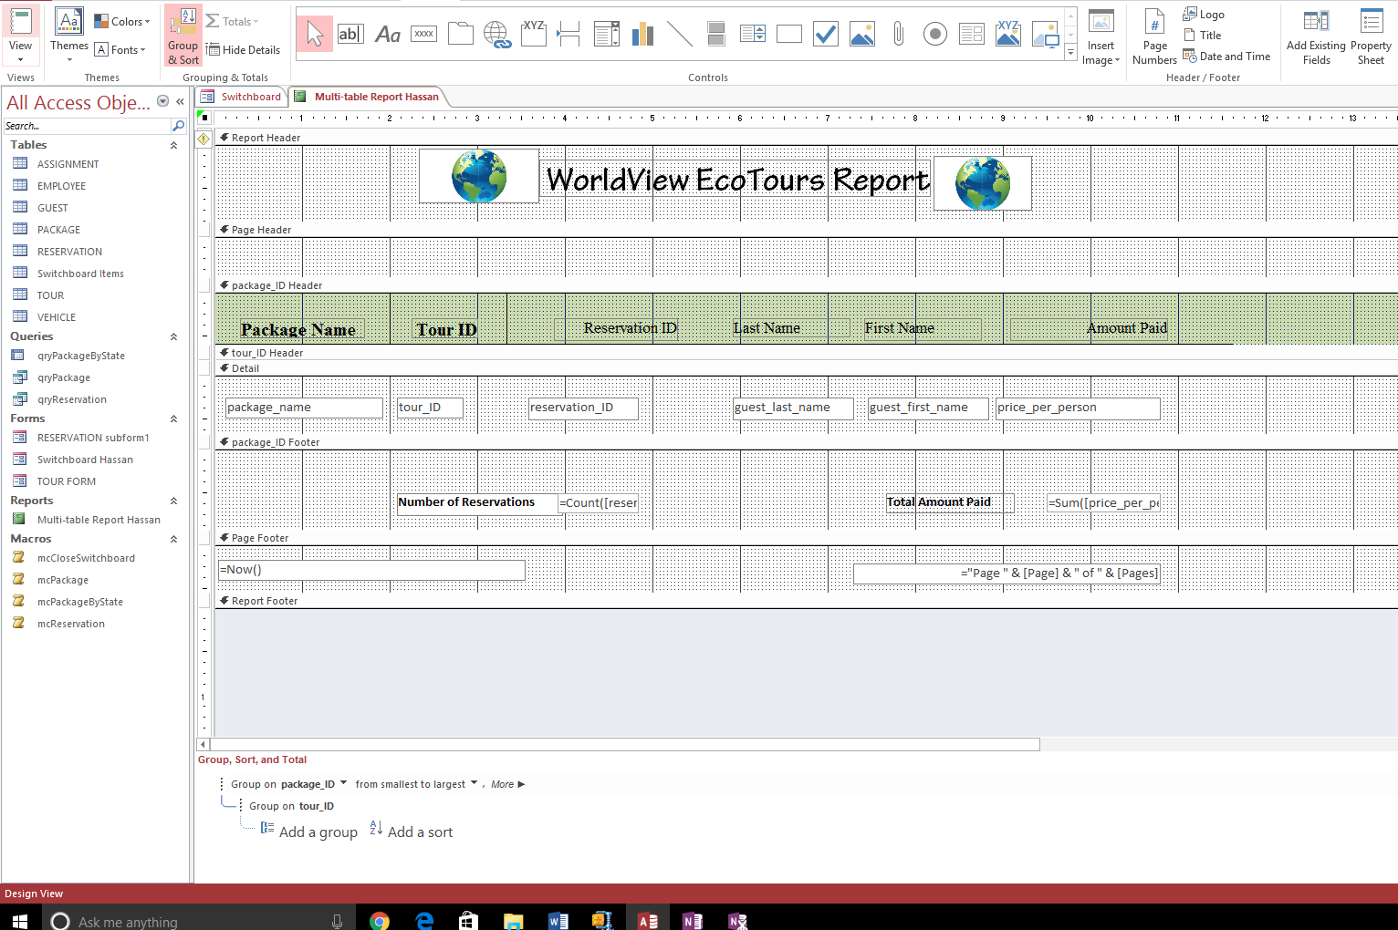

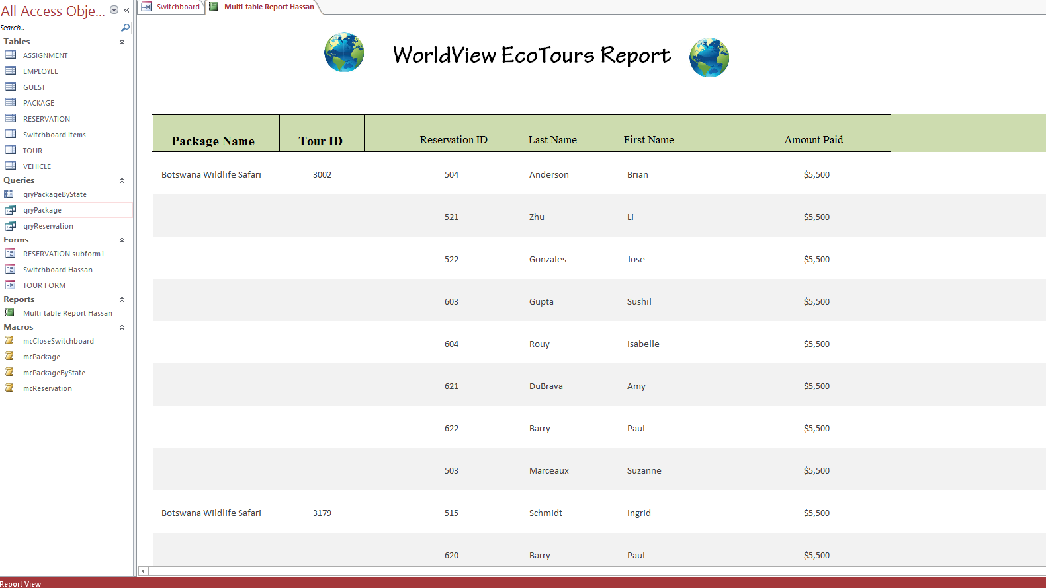

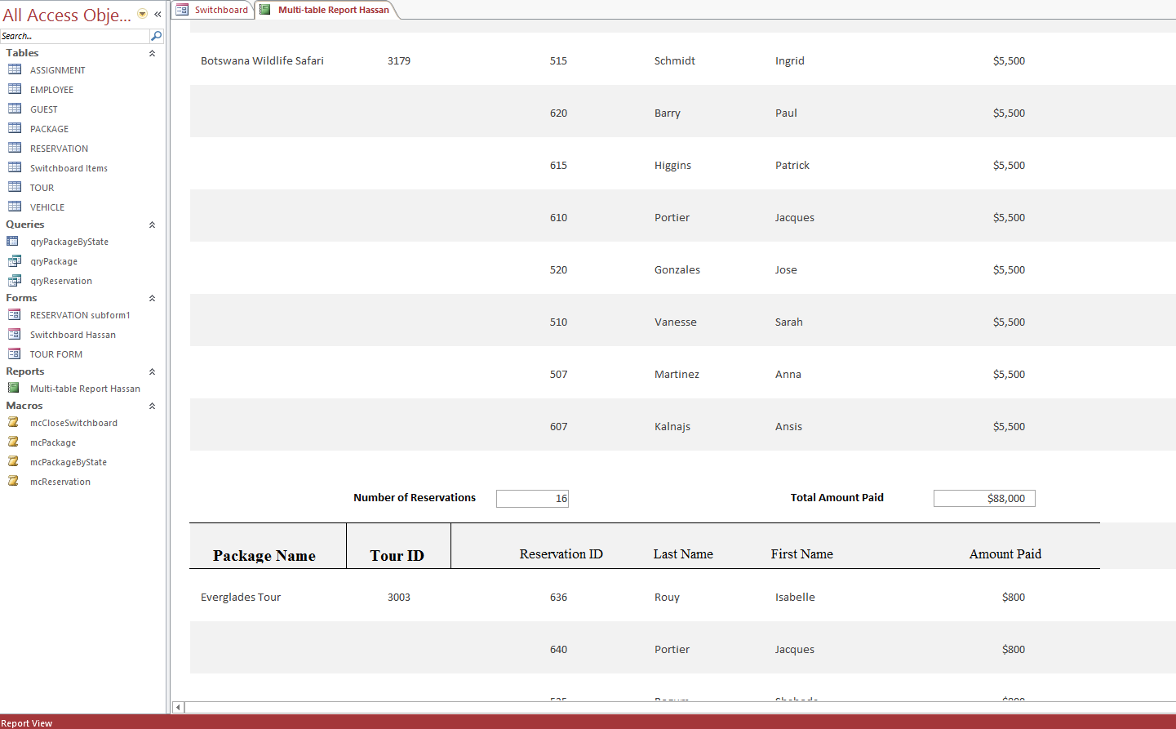

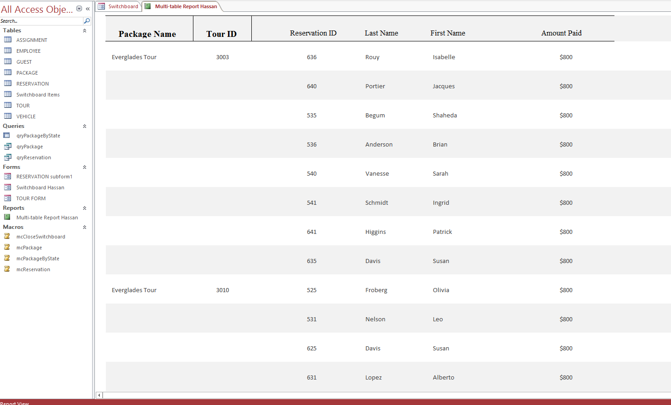

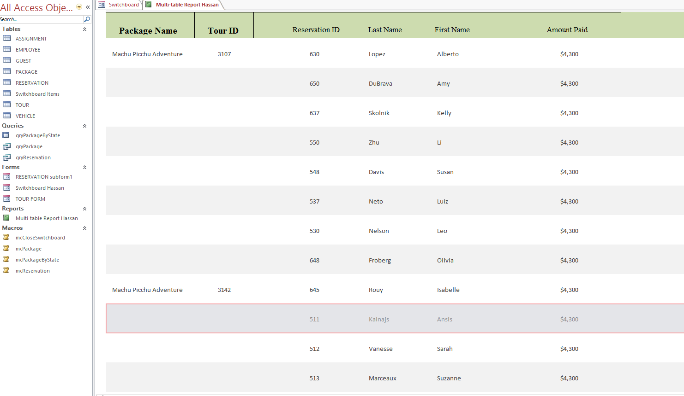

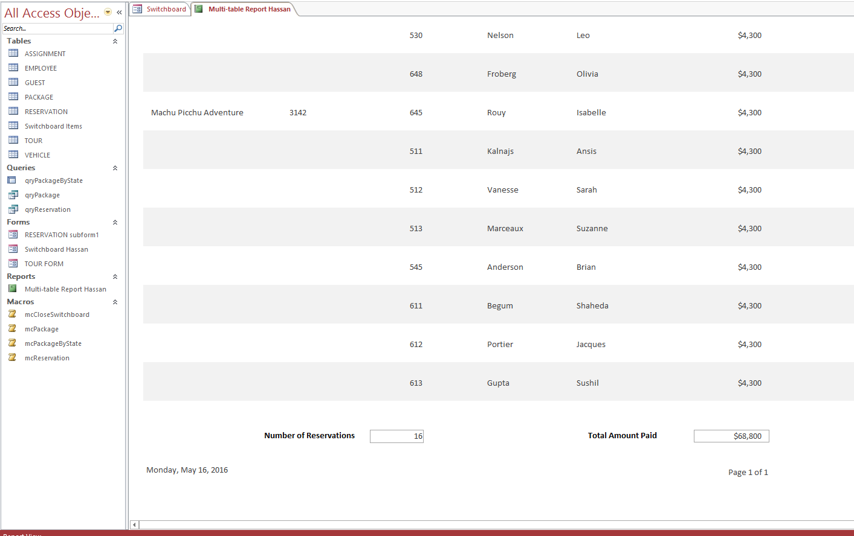

Switchboard

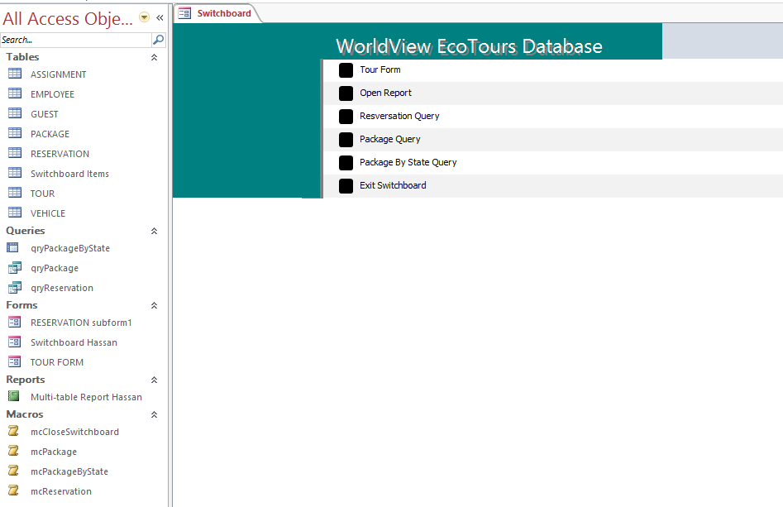

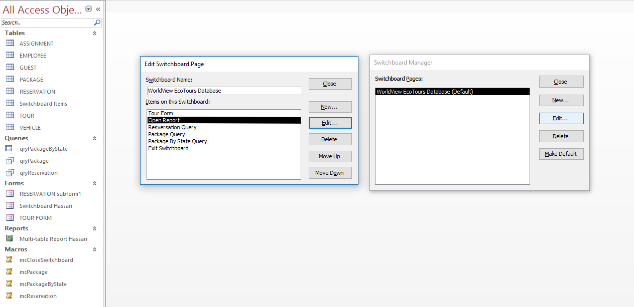

Macros for Switchboard

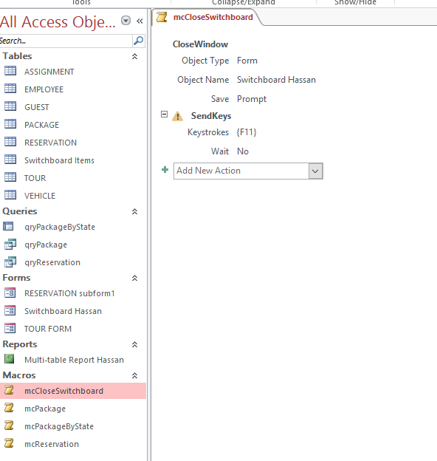

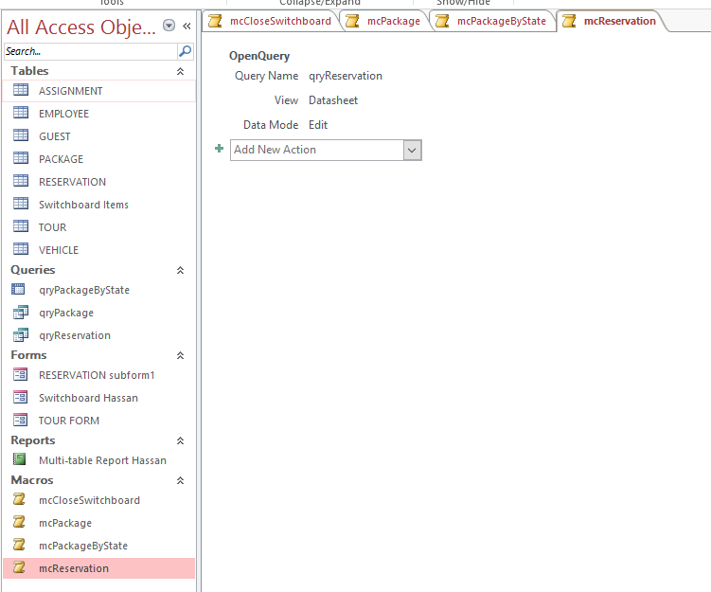

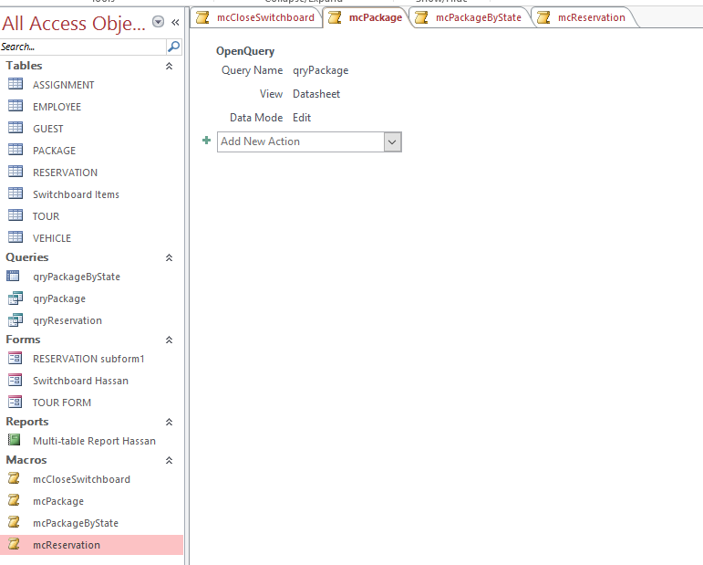

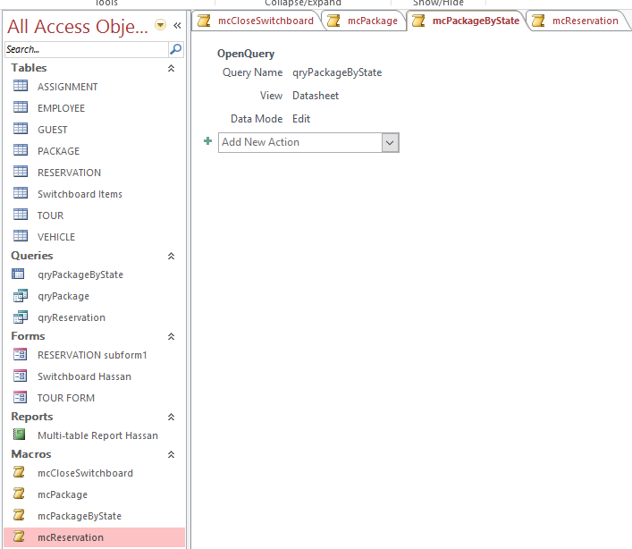

Conclusion

This project was a challenging experience as we did not have any background in designing a database. We learnt a lot as we progressed in designing this project. Drawing the ERD was a challenge in the beginning, especially figuring out the relationships. We had to make changes to the ERD a few times. Normalizing the relationships took us a few attempts to correct, but we finally got it. Creating the Tables was difficult in the beginning but as we progressed it started to become easier and we were better understanding how to link data from one table to another table. As we progressed in designing the database, things started to make sense. We started to see how we can make the reservations more informative by adding lookups. We enjoyed designing the Tables the most. We never imagined that we would be able to design a database, but now we feel very confident that we can design an effective functional database for a small company. If we had to do it all over again, we would not do anything differently as we are satisfied with the outcome of our database and are confident that WorldView EcoTours will be able to run their company much more effectively as the functionality of running their company will be all automated.

Log Sheet

Name Section worked on:

Shaheda Begum qryReservation and conclusion.

Hassan Tahir Multi-Table Report & Switchboard

Marek Martinek Tour Form & Reservation SubForm

Eric Hom qryPackageByState

Franklyn Eze qryPackage